Newsletter
September 2022 no 2
A Love of Learning for Life

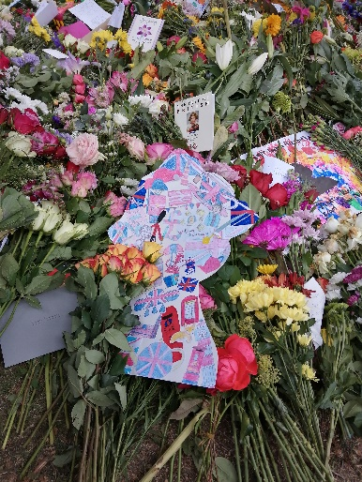
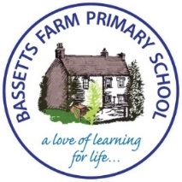
A Love of Learning…
Queens Tribute
A few weeks ago, a parent took
a tribute from the children at
Bassetts Farm to Hyde Park to lay a tribute
message for the Queen.
The Children drew iconic British
Images and arranged these into a
collage on the Queens head.

House Captains
Congratulations to our new House Captains. Throughout the school, the children are in one of 4 houses: Red, Yellow, Green or Blue. They can get house points during the week for amazing behaviour, learning or attitudes as well as in competitions or events like Sports Day.
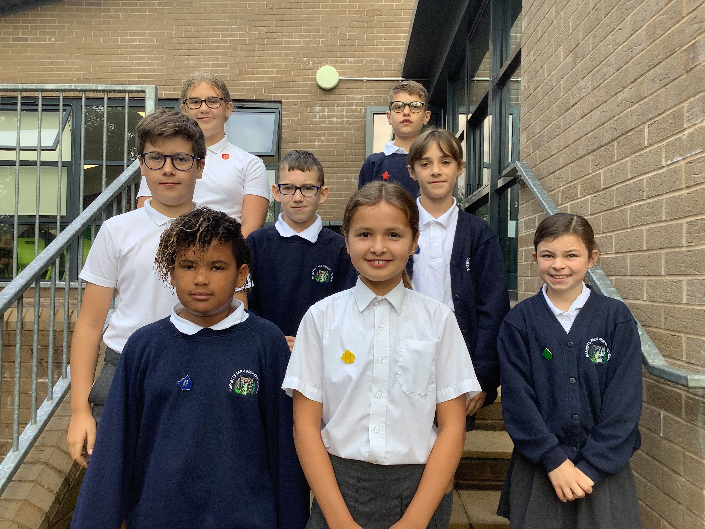

Flu Vaccinations:
Flu vaccination are available for all children in school. In order for your child to have this vaccination, you need to have registered and given consent using the following link.
If you have already given consent you do not need to repeat.
https://schoolimms.hcrgcaregroup.com/flu/2022/devon

Dear All,
Our Adventure Learning Journey is well underway. As well as learning about different countries in geography; Adventure Tales in English and coding in Computing, the children are also getting out and about. We are lucky to have wonderful grounds but also lovely woodlands close to school. Year 2 have been enjoying these woods and collecting conkers along the way.
Year 3 have been out to Bear Trail and had very muddy adventures; year 5 have enjoyed biking adventures. Next week, year 6 are off on a week’s residential to try new adventures and year 5 are off swimming.
No two weeks are ever the same at Bassetts!

Have a lovely weekend,

Mrs Sarah Bennett

Sports
Bike-ability
Ever year children in year 5 are given the opportunity for Bike-ability sessions. They learn how to safely ride their bike on the roads. A lifelong skill. This week, the trainers were very impressed with the concentration shown and the politeness of the children.
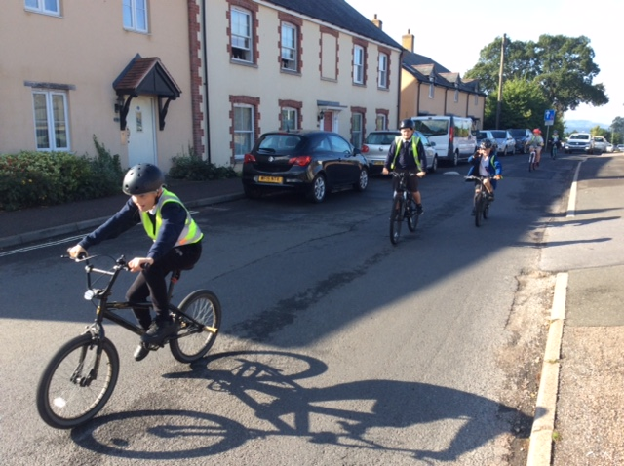

Play Equipment
Please do not allow your child to use the play equipment before or after school.
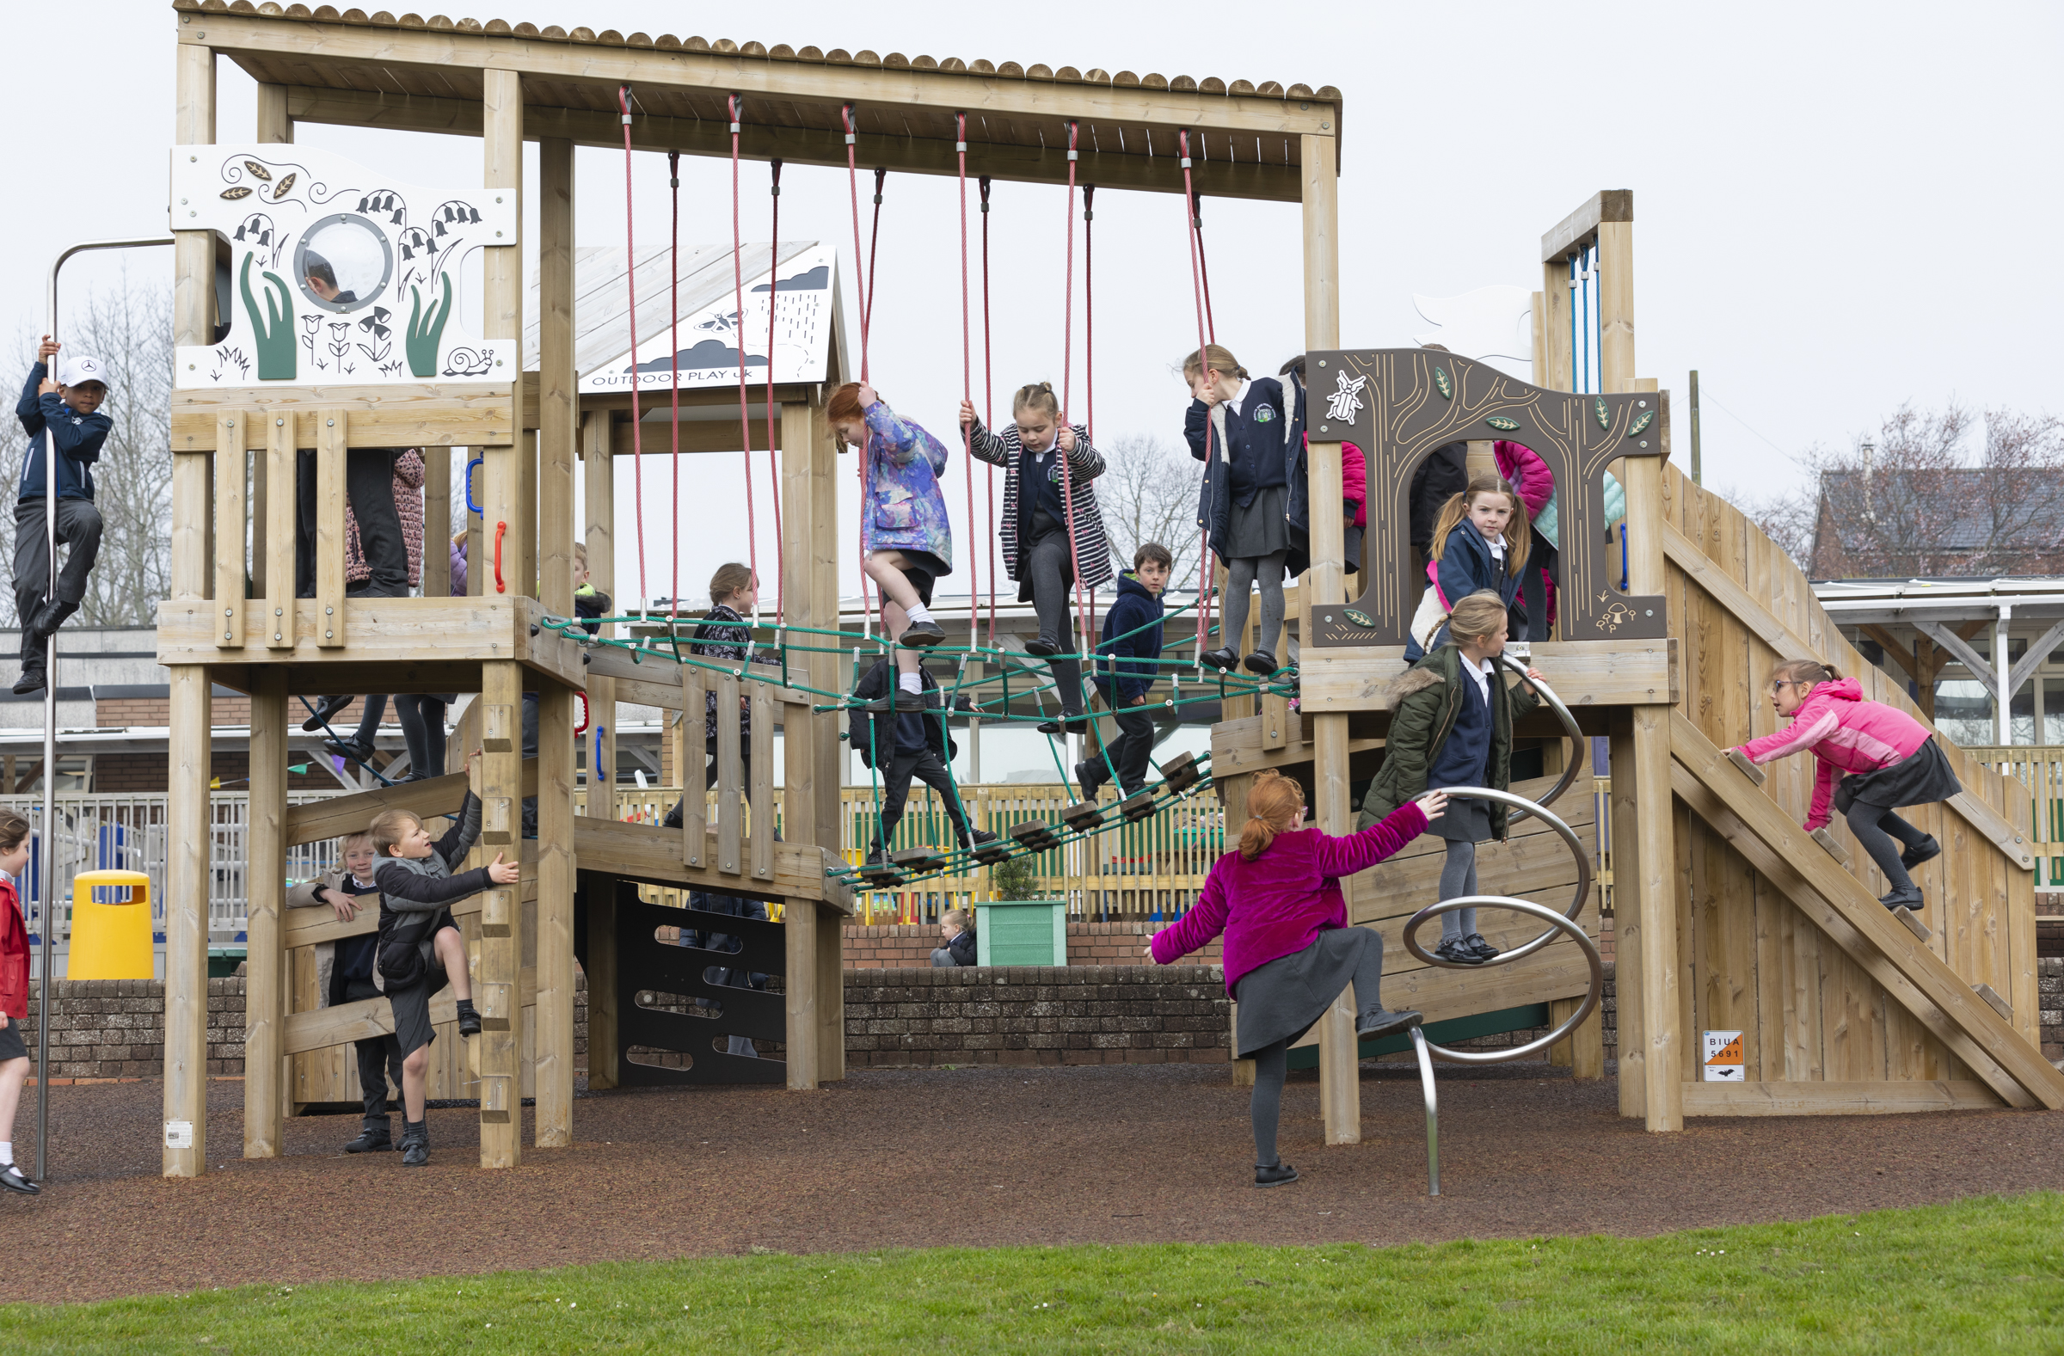

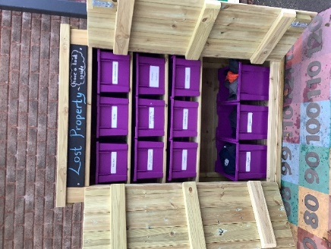
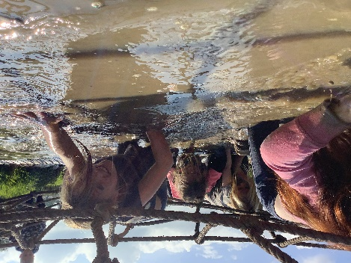
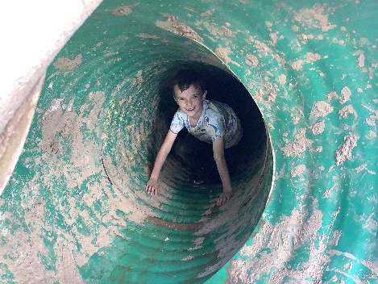
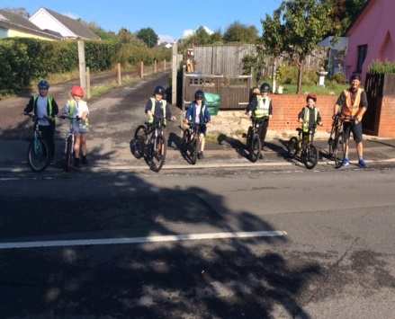
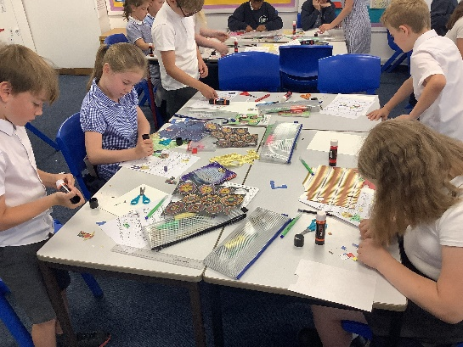
Lost Property,

Please ensure all uniform is labelled. If your child has lost a jumper etc, all named clothes can be returned. If it is unnamed, you might be able to find it in the lost property shed between year 3 classrooms and year 5/6 classrooms. Feel free to open and have a browse.

Bear Trail
On Friday 23rd of September Year 3 went to the Bear Trail and had lots of fun. There were stepping stones that were really easy to cross and I didn’t fall in. The zip wire was excellent because when I zoomed down it flung up really high. My favourite thing to do was the huge, green slide and I went on it lots of times. It went really fast into a pit of gooey mud. There was a rope to climb, and you had to ring the bell but I only got to the top once. I got really muddy, and I was super cold so I went to go and get a nice warm shower. Once everybody in my group was clean, we went to go and have lunch under an enormous, white tent. Then after I had finished all my lunch I went to go and play on the dry stuff. Once everybody had finished all their lunch, we had a tiny play and then we headed back to school.
By Alice Keay
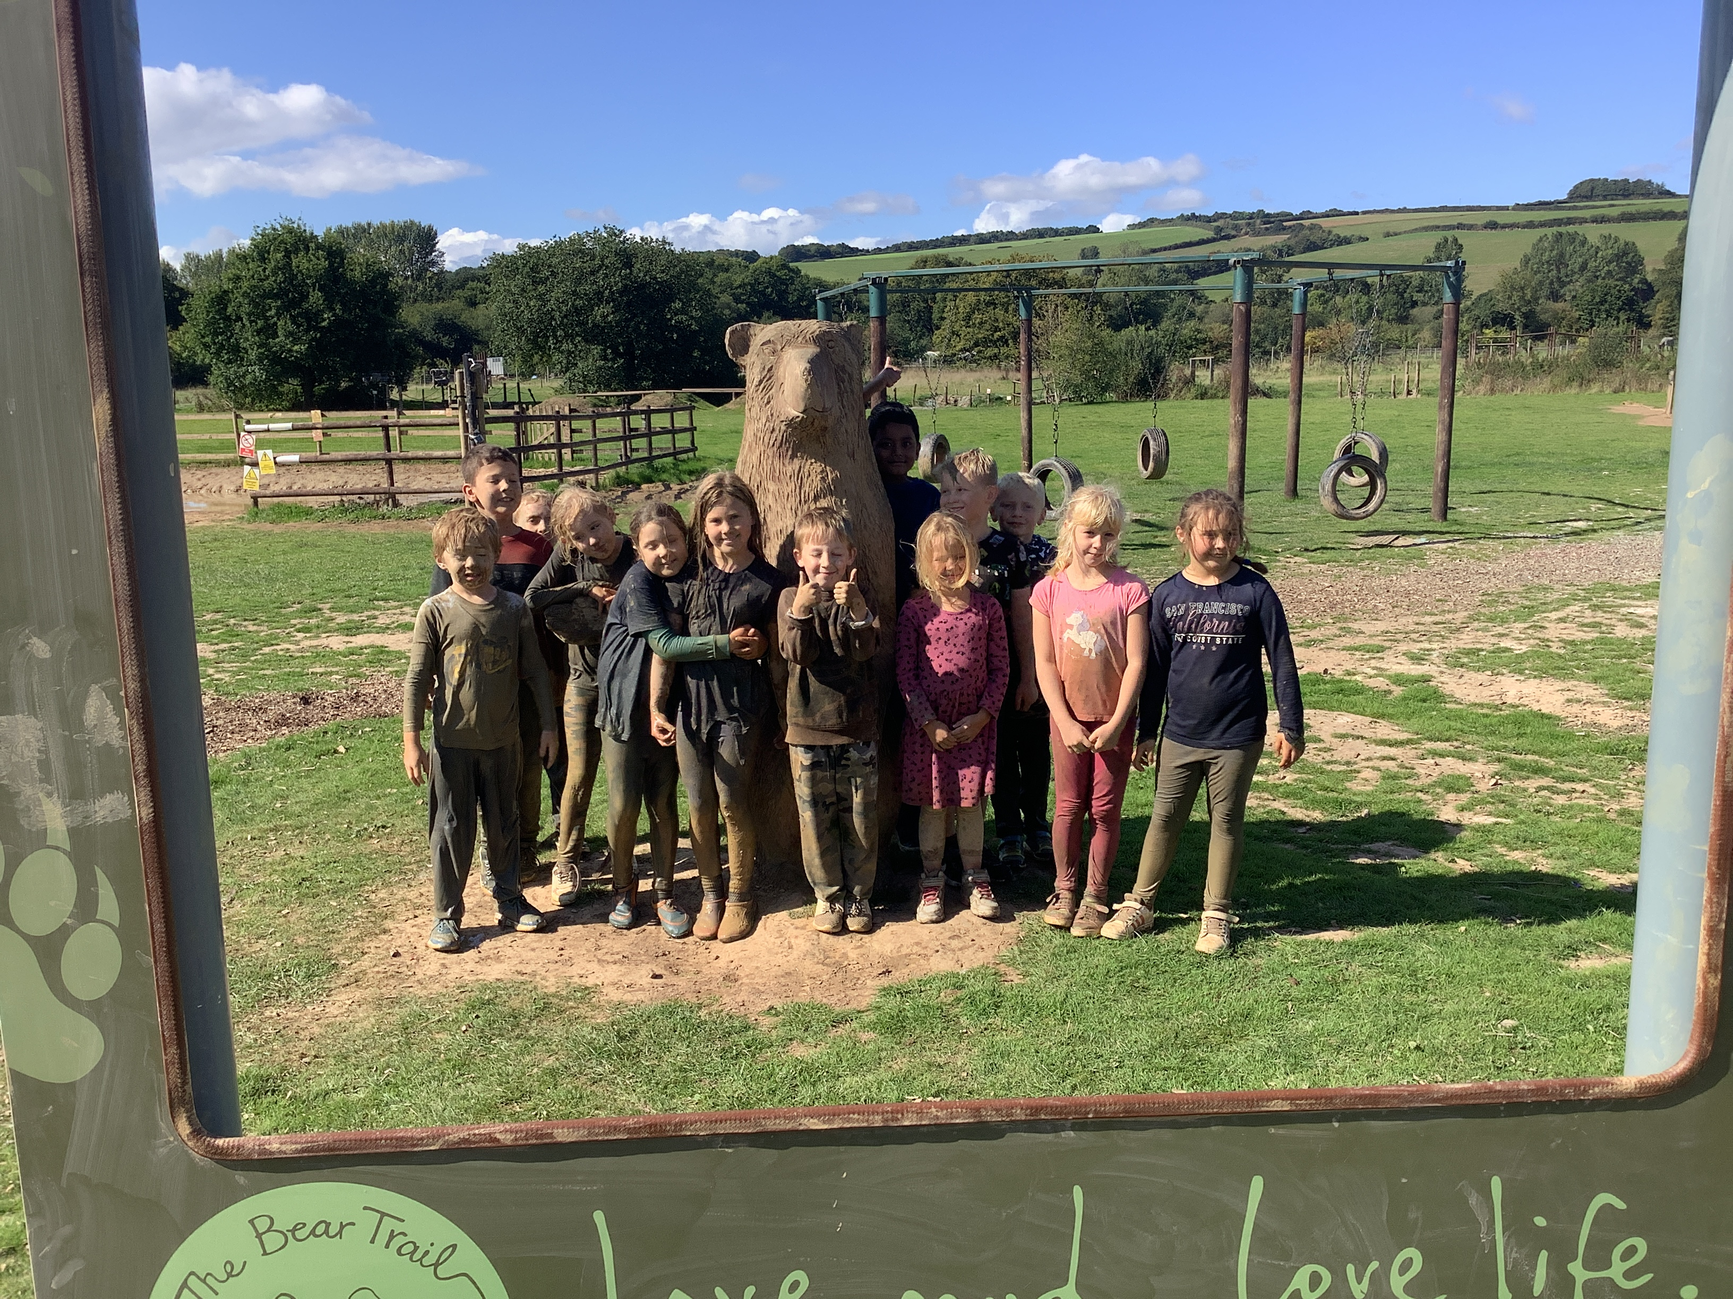

A Love of Learning…
Autumn 2022 Dates for the Diary…

October
Date | Time | Who | Event | Information
3rd-7th |  | Yr 6 | Residential to Grenville House | Arrival at school at usual time.
Wed 12th | 2:50pm | Yr 2 | Year 2 parent session to find out about life in year 3 and how to support your child
Thurs 13th |  | All | Flu Vaccinations | Please use the following link to give consent:  https://schoolimms.hcrgcaregroup.com/flu/2022/devon
Fri 14th | 9:00am | Year 6 | “We Present Our Learning” | 9:00- 9:20am in the Hall. Parents are welcome to join us to see photos from the recent residential.
Tues 18th  Wed 19th | 4-7pm | All | Parents’ Evening | An opportunity to talk with your child’s teacher about their progress and next steps.  A booking link will come out at the beginning of October.
17th- 21st |  | All | Grow a Pound Themed Week | Throughout the week, children will be deigning and making a product to sell. The profit made will be going to charity.
Thurs 20th | 3:10pm |  | Grow a Pound market place.
24th- 28th | Half Term
Mon 31st | Non Pupil Day

November
Date | Time | Who | Event | Information
Thurs 3rd | am | All | School Photographs | For individuals and siblings within school.
Fri 11th | 9:00 | Yr 3 | “We Present Our Learning” | 9:00- 9:20am in the Hall. Parents are welcome to join us.
Fri 25th | 9:00 | Yr 1 | “We Present Our Learning” | 9:00- 9:20am in the Hall. Parents are welcome to join us.
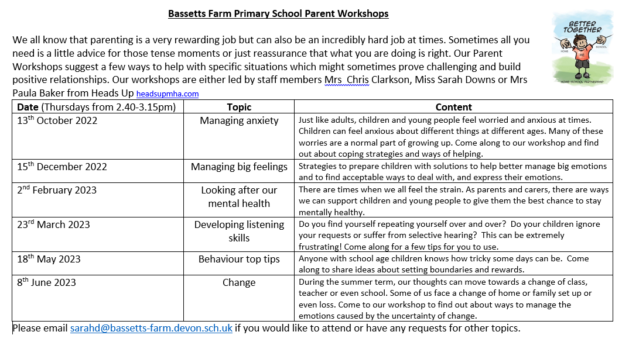
A Love of Learning…
Poppies and Sunflowers

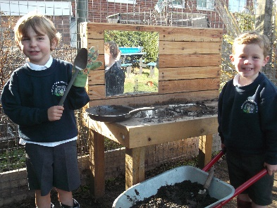
The children had a great time exploring the Early Years Garden. We are practising putting on our wellies before we head off!
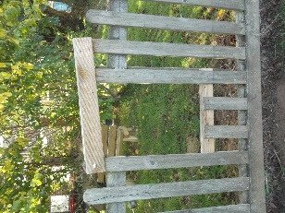
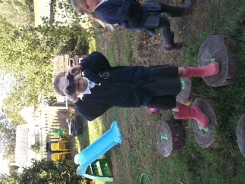
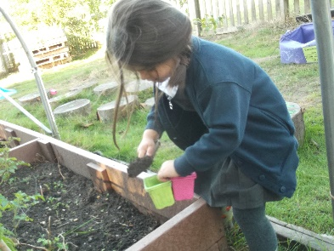

Year One
In art, Year One have been creating beautiful natural collages in the style of Andy Goldsworthy. Can you spot what the children have created and what they have used?

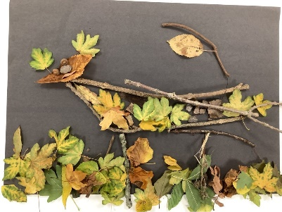
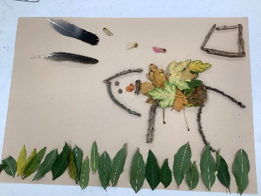
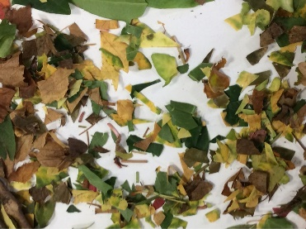

Year Two

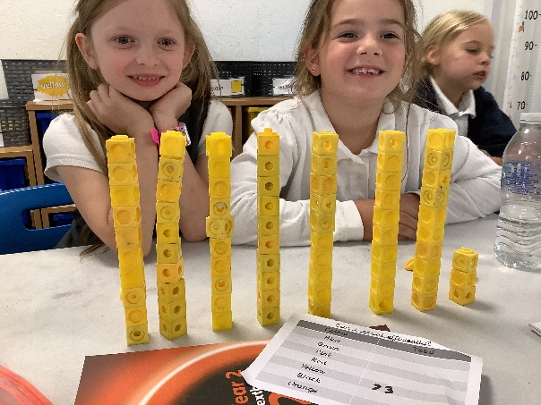
In Year 2 we have been exploring how to count efficiently using tens and ones. We have also been experimenting with representing two-digit numbers in different ways and have enjoyed spotting the odd one out in our representations.
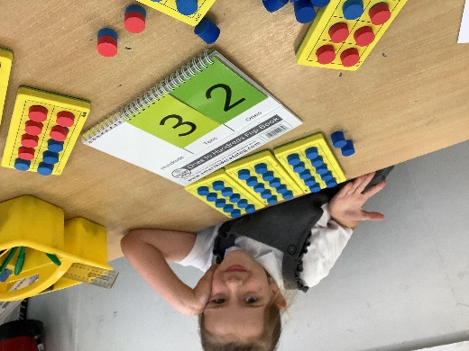

Year Three
Year 3 are loving their French lessons with Ms Capey. The children have learnt to ask how their friend is and how to give a simple reply.

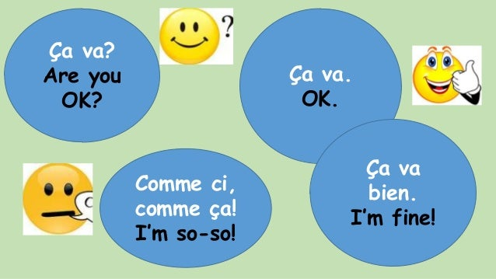
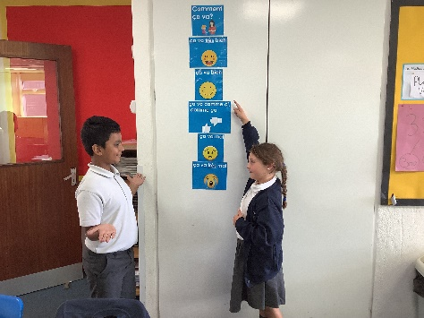

Year Four

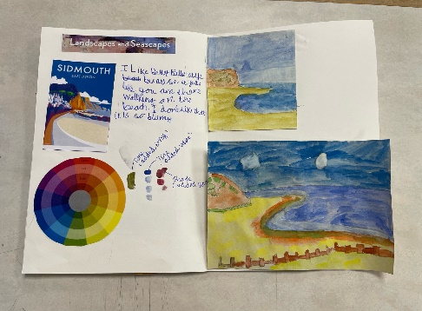
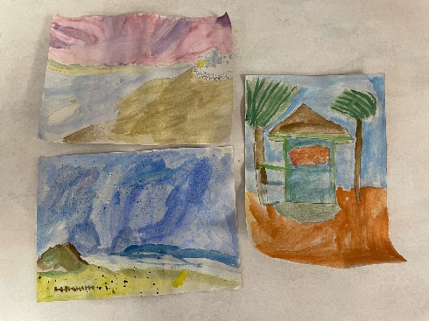
As part of our topic on 'Landscapes and Seascapes', Year 4 have been developing the use of watercolours by painting images of the local beach area. They used their knowledge of tints, shades and tone to help get the right colours.

Year Five Year Six
This week, in Geography, we have been comparing the climates of different regions of the UK.
We investigated rainfall and temperature in Exeter and Plymouth and also studied the climate of a farm located in the Cambrian Mountains.
We then presented this data in climate graphs

In maths, we have had lots of fun playing a version of connect 4. In order to lay our counters, we first used verbal reasoning to solve place value problems with our partners. The children were very competitive!
